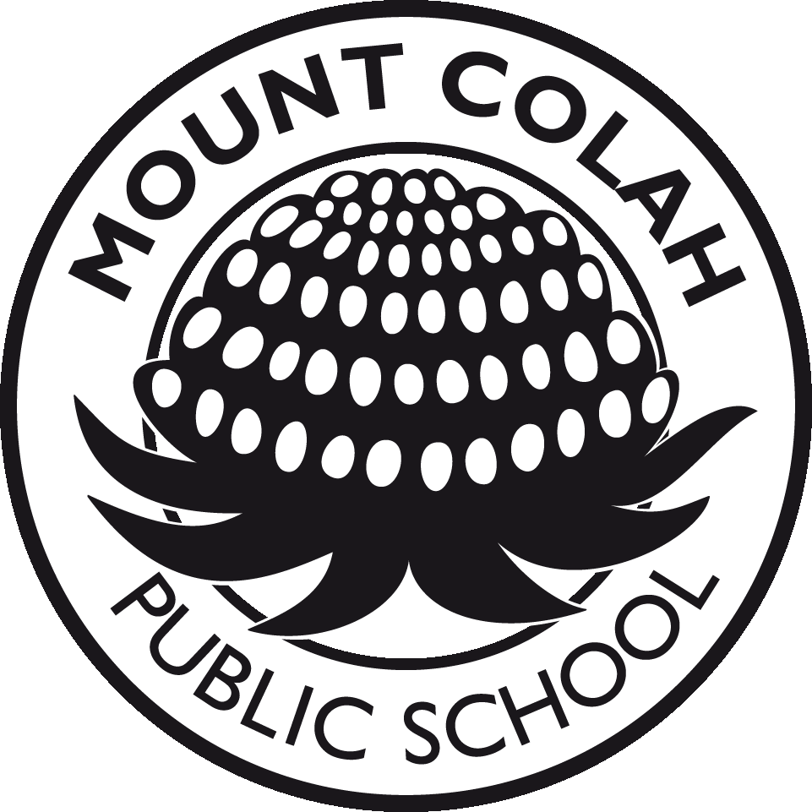 | Mount Colah Public School
 | Phone: 9477 3627  Fax: 9482 2528  Email: mtcolah-p.school@det.nsw.edu.au  Website: www.mtcolah-p.schools.nsw.edu.au | Telopea Street  Mount Colah  NSW 2079

Each year we seek permission from parents for their children to participate in a range of activities. It is important that you carefully read the information below and sign the consent forms if you agree to your child participating in the activities and\or school programs. Only those children whose parents or caregivers have signed and returned the consent forms will be able to undertake the activities.

Dr John Paterson
Principal

SCRIPTURE
Schools are required by law to provide weekly religious instruction for children. Parents have the right to withdraw their children from these lessons. You only need to complete this question if this is your child’s first year at our school.

LOCAL EXCURSIONS
At various time during the year the children may be involved in a class activity that requires them to leave the school grounds. This could include walking to a local oval for sport, competing in the school cross country or exploring the local community. At all times the children will be supervised by a teacher.

PERMISSION TO WATCH PG MOVIES
Occasionally teachers wish to show movies to their class for a variety of reasons, for example as a comparison to a story that has been studied in class or relating to a topic in class. Many movies that the children watch these days have been rated PG but this means teachers are not permitted to show them without parental permission. They are usually perfectly suitable for the children to watch, many are related to stories the children have read and most children have already seen them eg James and the Giant Peach, Matilda and Shrek. We request your permission to show movies with a PG rating to your child that the teacher deems to be suitable for the age group.

PERMISSION TO PUBLISH STUDENT PHOTOGRAPHS
We are seeking your permission to allow the school/Department of Education and Communities to publish and/or disclose information about your child for the purposes of sharing his/her experiences with other students, informing the school and broader community about school and student activities and recording student participation in noteworthy projects or community service.
This information may include your child’s name, age, class and information collected at school such as photographs, sound and visual recordings of your child, your child’s work and expressions of opinion such as in interactive media.
The communications in which your child’s information may be published or disclosed include but are not limited to:
- Public websites of the Department of Education and Communities including the school website, the Department of Education and Communities intranet (staff only), blogs and wikis
- Department of Education and Communities publications including the school newsletter, annual school magazine and school report, promotional material published in print and electronically including on the Department’s websites
- Official Department and school social media accounts on networks such as YouTube, Facebook and Twitter
- Local and metropolitan newspapers and magazines and other media outlets

Parents should be aware that when information is published on public websites and social media channels, it can be discoverable online for a number of years, if not permanently. Search engines may also cache or retain copies of published information. Published information can also be linked to by third parties.
NB Should you not give permission to publish your child’s photograph then their image will be blurred in the school YearBook. Please feel free to contact me if you need to discuss this issue.

2018 STUDENT PERMISSION NOTES

Student’s Name: ___________________________________________________Class: __________

SCRIPTURE (please tick the appropriate box ONLY IF THIS IS YOUR CHILD’s FIRST YEAR AT MCPS)
I wish my child to attend
General Protestant Catholic Non-Scripture (a letter Scripture Classes Scripture Classes is required if you do not
wish your child to attend
either of these classes)
Ethics (on a limited basis, drawn only from Non-Scripture)

LOCAL EXCURSIONS (please tick the appropriate response)
I give / don’t give permission for my child to leave the school grounds to participate in school related activities within the local area. I understand that the students will be under the supervision of a teacher during the activities.

PERMISSION TO WATCH PG MOVIES (please tick the appropriate response)
I give / don’t give permission for my child to watch PG movies deemed to be suitable by the teacher. I understand that if I don’t give permission my child will be given alternative activities to do.

PERMISSION TO PUBLISH (includes STUDENT PHOTOGRAPHS)
I have read this permission to publish and: (tick the appropriate box)
I give permission I don’t give permission
to the school/Department of Education and Communities to publish information about my child as described overleaf, including in publicly accessible communications.
I understand that if I do not give permission then my child’s photograph will be blurred in the school YearBook.

This signed permission remains effective until I advise the school otherwise.
Parent’s Name (Please print) ________________________________________________________
Signature ______________________________________ Date _____________________________

