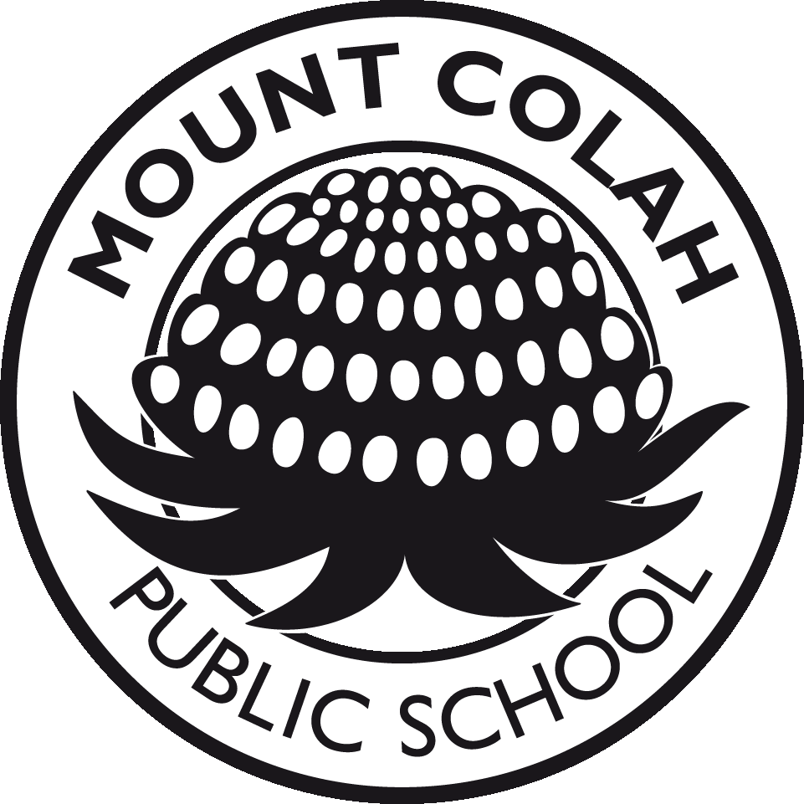
Mount Colah Public School
Phone 9477 3627  Fax: 9482 2528  Email: mtcolah-p.school@det.nsw.edu.au  Website: www.mtcolah-p.schools.nsw.edu.au | Telopea Street  Mount Colah  NSW 2079
2018 SCHOOL CURRICULUM CONTRIBUTION

As you are aware this year we are trialling a new bookpack system for the various grades. However in addition to the textbooks there are additional costs that the school faces which are not included in the bookpacks. Some items could not be billed with the book packs as they represent some classroom consumables or relate to other areas of operation in the school such as the library. Each year government funding is provided to cover the costs associated with the education of students at our school. Because these funds do not cover all our costs we rely heavily on financial support from the P&C Association, and money collected as part of the school curriculum contribution, to ensure we are able to provide for the needs of all students. The school curriculum contribution covers such things as the cost of some class workbooks, art and craft materials, some classroom consumables, computer levy, technology levy and online subscriptions to some websites (others have already been included in the bookpacks ). The school curriculum contribution for each grade in 2018 has been set out as attached. So that we can continue to provide our students with the best possible environment in which to grow and develop we would appreciate it if parents could make payment as soon as possible.

John Paterson - Principal

P&C SCHOOL RESOURCE FUND & LIBRARY FUND

Whilst we are aware that “back to school” is an expensive time for all families, additional funding for school resources and improvements is still required. Unfortunately, the money allocated by the Government covers only the bare basics of running the school. To ensure that our children continue to access the best possible resources, we ask you to support the P&C School Resource Fund and Library Fund.

The School Resource Fund has been set by the P&C Association at:-
$40 - 1st child; $30 - 2nd child; $20 - 3rd child. All subsequent children free.

The School Library Fund has been set at :-
$20 per student (please note that contributions to this fund are tax deductible.)

P&C Membership
Membership of the P&C entitles you to express your views at our meetings and to vote on any motions proposed at our meetings. A minimal rate of 50c per adult is required. We encourage all parents and carers to join the P&C. All families who contribute to the P&C School Resource Fund will receive a copy of the 2018 School YearBook free of charge. Your support for these funds is appreciated.

Parents are reminded that payment is voluntary.

Phil Dobrinic – P&C President, 2017

The School Curriculum Contribution, P&C Resource Fund and Library Fund and cost of textbooks can be combined for all students in a family as one payment if parents prefer to pay everything together.

Payment of the School Curriculum Contribution, the P&C Resource Fund and the Library Fund can be organised on a term basis if families are unable to pay the total cost of all contributions at one time. Enquire at the office if you wish to take up this option.

It would be preferred if payments could be handed in at the school office. However, payments can be placed in the locked green money collection box located in your child’s classroom. Parent Online Payments (POP) (preferred method) is available through the schools website, EFTPOS facilities are no longer available. Please complete the accompanying payment slip to assist with receipting.

We appreciate your continued support in this matter.

MOUNT COLAH PUBLIC SCHOOL

SCHEDULE OF CONTRIBUTIONS – 2018 PLEASE RETURN TO THE SCHOOL OFFICE

NAME OF STUDENTS: _________________________________________ Year _____Class______

_________________________________________ Year _____Class______

_________________________________________ Year _____Class______

SCHOOL CURRICULUM CONTRIBUTION | Amount | Amount to  be paid
Kindergarten | $55.00
Grade 1 | $15.00
Grade 2 | $15.00
Grade 3 | $45.00
Grade 4 | $45.00
Grade 5 | $45.00
Grade 6 | $45.00
P&C RESOURCE FUND – as determined by the P&C

First child | $40.00
Second child | $30.00
Third child | $20.00
P&C MEMBERSHIP | $0.50 per person
LIBRARY FUND | $20.00 per child
TEXTBOOKS – This section only applies if you have not purchased your Book Packs online

Kindergarten | $42.25
Year 1 | $78.15
Year 2 | $96.05
Year 3 | $47.95
Year 4 | $48.00
Year 5 | $38.70
Year 6 | $38.70
TOTAL

- I have added other payments for ______________________________________ ______________

______________________________________ ______________

□ I have made an online payment (preferred method). The receipt number is _________________________ date _____________

□ I have enclosed cash/cheque as payment. Please make cheques payable to NSW Government Schools.

GRAND TOTAL __________________

